

EMPLOYEE ATTENDANCE MANAGEMENT SYSTE

*a Mobile Application Project report*

***submit by***

# Saurabh Yadav

***Project guide***

**Teamlead :- BK. Vishwakarma**

**TABLE OF CONTENTS**

|  |  |  |
| --- | --- | --- |
| **CHAPTER NO** | **TITLE** | **PAGE NO** |
|  | **ABSTRACT** | **vii** |
|  | **LIST OF FIGURES** | **viii** |
|  | **LIST OF TABLES** | **ix** |
| **1** | **INTRODUCTION** | 1 |
|  | 1Objective | 1 |
| **2** | **SYSTEM ANALYSIS** | **2** |
| **3** | **SYSTEM SPECIFICATION** | **5** |
|  | 3.1 Hardware Specification | 5 |
|  | 3.2 Software Specification | 5 |
| **4** | **SOFTWARE DESCRIPTION** | **6** |
|  | 4.1Package-VS Code 2022 | 6 |
|  | 4.2 Development Tools And Technologies | 6 |
| **5** | **PROJECT DESCRIPTION** | **9** |
|  | 5.1 Problem Definition | 9 |
|  | 5.2 Overview of The Project | 9 |
|  | 5.3 Module Description | 9 |
|  | 5.4 System Flow Diagram | 12 |
|  | 5.5 Data Flow Diagram | 13 |

|  |  |  |
| --- | --- | --- |
|  | 5.6 System Design | **15** |

# LIST OF TABLES

|  |  |  |
| --- | --- | --- |
| **Chapter** | **Contents** | **Page no** |
| **5.7.2.1** | Log In Table | 17 |
| **5.7.2.2** | Department Table | 17 |

|  |  |  |
| --- | --- | --- |
| **5.7.2.3** | Student Table | 18 |
| **5.7.2.4** | Attendance Table | 19 |
| **5.7.2.5** | Leave Table | 20 |

**ABSTRACT**

**Employee attendance management** system deals with the maintenance of the Employee attendance details. It is generates the attendance of the Employee on basis of presence in Office. It is maintained on the daily basis of their attendance. The Department will be provided with the separate user name & password to make the Employee status.

The Department handling the Team Employee responsible to make the attendance or Leave data for all Employee.

## CHAPTER 1

**INTRODUCTION**

“Attendance Management System” is software developed for maintaining the attendance of the Employee on the daily basis in the Office. Here the Department, who are handling All Team Employee, will be responsible to handle attendance and Leave of the Employee. Each Department will be given with a separate user name or employee Id and password based on the Team handle.

# CHAPTER 2

* **SYSTEM ANALYSIS :-**

## EXISTING SYSTEM

The Existing system is a manual entry for the Employee. Here the attendance will be carried out in the hand written registers. It will be a tedious job to maintain the record for the user. The human effort is more here.

The retrieval of the information is not as easy as the records are maintained in the hand written registers.

This application requires correct feed on input into the respective field. Suppose the wrong inputs are entered, the application resist to work. So the user find it difficult to use.

### PROPOSED SYSTEM:

To overcome the drawbacks of the existing system, the proposed system has been evolved. This project aims to reduce the paper work and saving time to generate accurate results from the Employee's attendance. The system provides with the best user interface.

The efficient reports can be generated by using this proposed system.

### Advantages of Proposed System

* + - * It is trouble-free to use.
      * It is a relatively fast approach to enter attendance
      * Is highly reliable, approximate result from user
      * Best user Interface
      * Efficient reports

### FEASIBILITY STUDY:

Feasibility analysis begins once the goals are defined. It starts by generating broad possible solutions, which are possible to give an indication of what the new system should look Time. This is where creativity and imagination are used. Analysts must think up new ways of doing things- generate new ideas. There is no need to go into the detailed system operation yet. The solution should provide enough information to make reasonable estimates about project cost and give users an indication of how the new system will fit into the organization. It is important not to exert considerable effort at this stage only to find out that the project is not worthwhile or that there is a need significantly change the original goal.

Feasibility of a new system means ensuring that the new system, which we are going to implement, is efficient and affordable. There are various types of feasibility to be determined. They are,

### Economically Feasibility:

Development of this application is highly economically feasible. The only thing to be done is making an environment with an effective supervision. It is cost effective in the sense that has eliminated the paper work completely. The system is also time effective because the calculations are automated which are made at the end of the month or as per the user requirment.

### Technical feasibility:

The technical requirement for the system is economic and it does notice any other additional Hardware and software. Technical evaluation must also assess whether the existing systems can be upgraded to use the new technology and whether the organization has the expertise to use it.

Install all upgrades framework into the Flutter package supported widows based application.

### Operational Feasibility :

The system working is quite easy to use and learn due to its simple but attractive interface. User requires no special training for operating the system. Technical performance include issues such as determining whether the system can provide the right information for the Department personnel Employee details, and whether the system can be organized so that it always delivers this information at the right place and on time using intranet services. Acceptance revolves around the current system and its personnel.

# CHAPTER 3

* **SYSTEM SPECIFICATION :-**

## HARDWARE REQUIREMENTS (Minimum Requirement)

### Minimum RAM:-8GB

* + - **SSD Disk:-**128 GB
    - **Processor:-** Intel

## SOFTWARE REQUIREMENTS (minimum Requirement)

* + - **Operating system :** Windows 10
    - **Front Design:** Flutter framework 3.3.0 , Android Studio Emulator
    - **Front-End Language :** Dart 2.18.0
    - **Back-End :** My SQL 8.0,
    - **Back-End Connectivity:** Dart 2.18.0

# CHAPTER 4

* **SOFTWARE DESCRIPTION :-**

## PACKAGE - V.S Code 2022

**V S Code version -1.70.1** is Integrated [development environment](https://en.wikipedia.org/wiki/Integrated_development_environment) (IDE) from [Microsoft](https://en.wikipedia.org/wiki/Microsoft). It is using to develop [console](https://en.wikipedia.org/wiki/Console_application) and [graphical](https://en.wikipedia.org/wiki/Graphical_user_interface)

along [Forms](https://en.wikipedia.org/wiki/Windows_Forms) or [WPF](https://en.wikipedia.org/wiki/Windows_Presentation_Foundation) applications, [we](https://en.wikipedia.org/wiki/Web_application)b [applications,](https://en.wikipedia.org/wiki/Web_application) and [web](https://en.wikipedia.org/wiki/Web_service) in both [native](https://en.wikipedia.org/wiki/Native_code) [code](https://en.wikipedia.org/wiki/Native_code) together with [managed](https://en.wikipedia.org/wiki/Managed_code) code for all platforms supported by [Microsoft](https://en.wikipedia.org/wiki/Microsoft_Windows) V S code supports different [programmin](https://en.wikipedia.org/wiki/Programming_language)g [languages](https://en.wikipedia.org/wiki/Programming_language) by means of language services, which allow the code editor and debugger to support (to varying degrees) nearly any programming language, provided a language-specific service exists.

V S Code also includes a web-site editor and designer that allows webpages to be authored by dragging and dropping widgets.

### My SQL 8.0:

My SQL 8.0 has come with purpose of improving manageability and performance in all areas, right from the process of installation, server configuration,

Data base upgrades to application tuning, space and storage management and so on. This My SQL version has been designed to reduce the cost of manageability and deliver high performance for all key workloads.

* Server manageability
* Storage management
* Space, object transaction management
* Back up recovery management
* Reduce down time for application and database upgrade

# CHAPTER 5

* **PROJECT DESCRIPTION**

## PROBLEM DEFINITION:

This system developed will reduce the manual work and avoid redundant data. By maintaining the attendance manually, then

efficient reports cannot be generated. The system can generate efficient,

consolidate report based on the attendance. As the attendances are maintained in registers it has been a tough task for admin and Department to maintain for long time. Instead the software can keep long and retrieve the information when needed.

## PROJECT OVERVIEW

Attendance Management System basically has two main modules for proper functioning

* + - Admin module is has rights for creating any new entry of faculty and employee details.
    - User has a rights of making daily attendance and Leave, generating report. Attendance report can be taken by given details of Employee details.

## MODULE DESCRIPTION

The system should be designed in such a way that only authorized people should be allowed to access some particular modules. The records should be modified by only administrators and no one else. The user should always be in control of the application and Leave data. The user interface should be consistent so that the user can handle the application with ease and speed. The application should be visually, conceptually clear.

### ADMINISTRATOR MODULE:

* + **Employee Details:**

In this module deals with the allocation of roll no and personal details for new batch. It will generate of personal details of student and academic details of the students with the photos.

### Department Details:

* + - It helps to allot the team and the department code to the particular Department.
    - It provides the facility to have a user name and password to the department.

### Attendance details:

* + - It will be makes to the attendance database all students. Entered attendance to store in the database subject, period wise into the particular date.
    - It will help to the get report of weekly and consolidate of the attendance.

### Leave details:

* It will retrieve all Employee Leave request data store Leave data information.

### Report details:

* + Report can be taken by daily, weekly and consolidate:
  + weekly report get all hour details of attendance starting date to ending date and display the status
* Consolidate report get all Employee attendance details starting date to ending date status.

### DEPARTMENT MODULE:

* + **Attendance details:**
    - It assists the Department to mark attendance to the Employee .This will authenticate the Department before making the entry.

### Report details:

* + - Report get particular hour details of attendance from starting date to ending date and display the status.
    - Consolidate report get all Employee attendance details from starting date to ending date status.

## SYSTEM FLOW DIAGRAM:

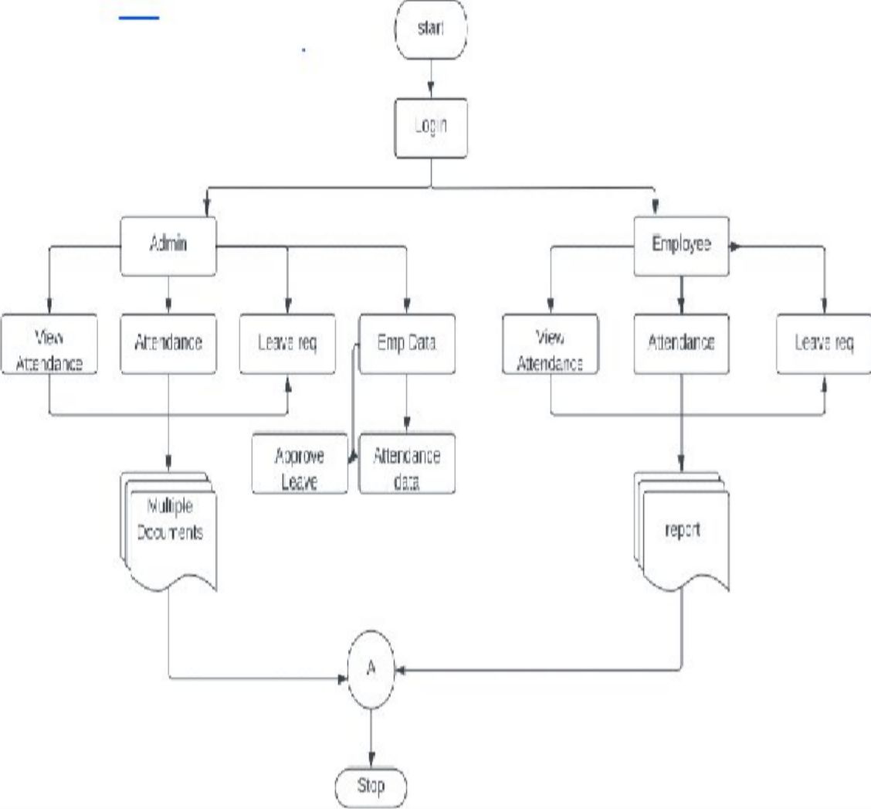

Figure - System Flow Diagram

## Data Flow Diagram

### DFD level 0:

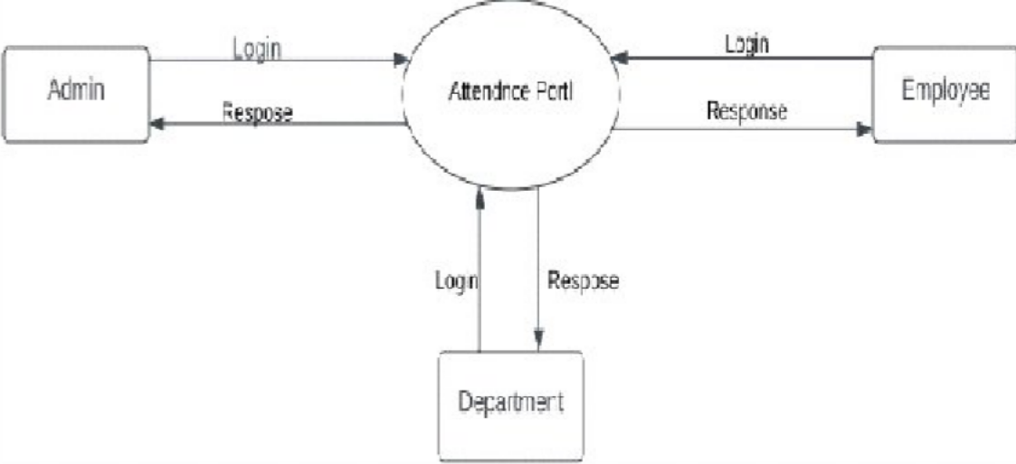

Figure -Data Flow Diagram Level

### DFD level 1:

* **Admin:**

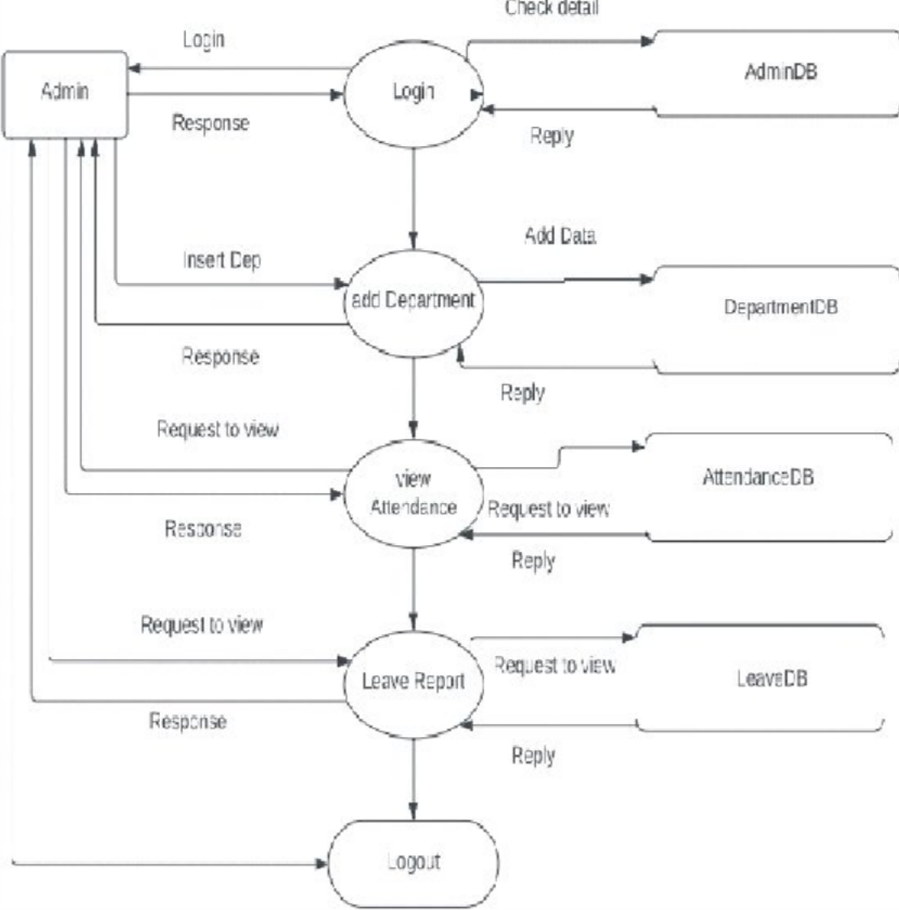

Figure - Data Flow Diagram Level1

### DFD level 2:

* **Department:**

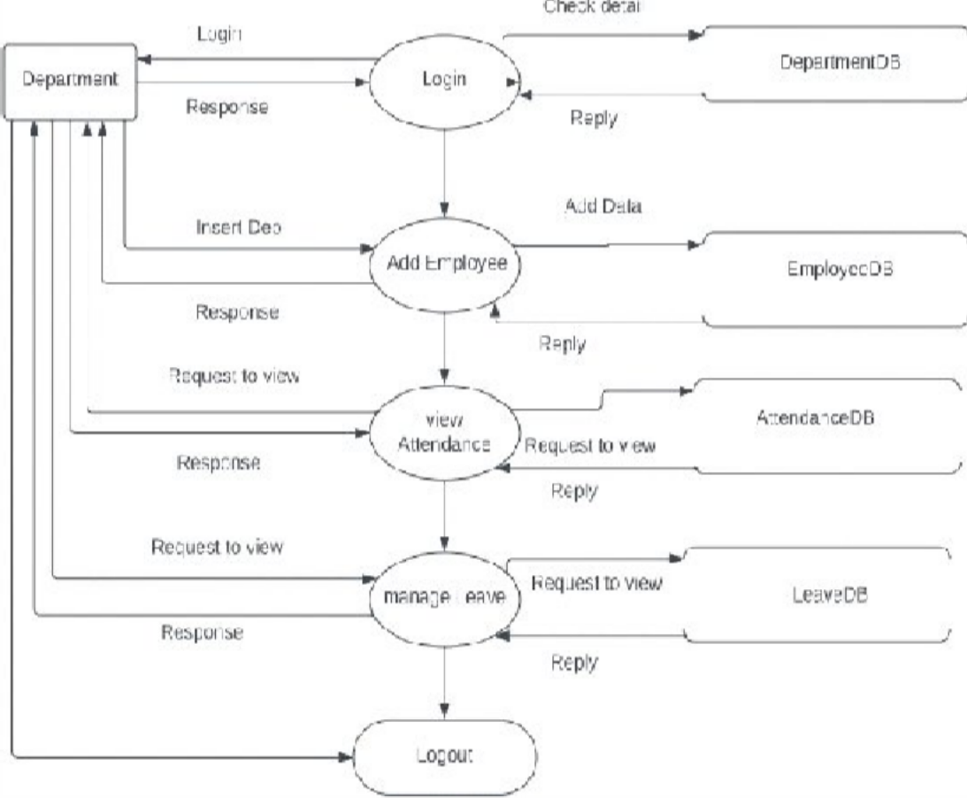

Figure -Data Flow Diagram Level2

### Employee:-

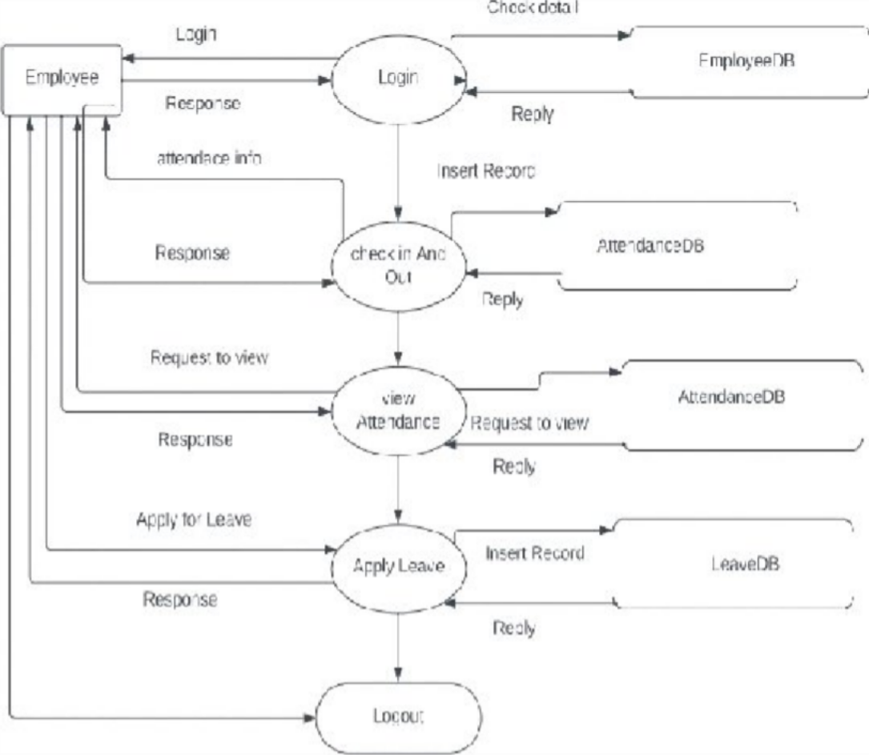

Figure - Data Flow Diagram Level2

## SYSTEM DESIGN:

* + **Entity Relationship Diagram:**

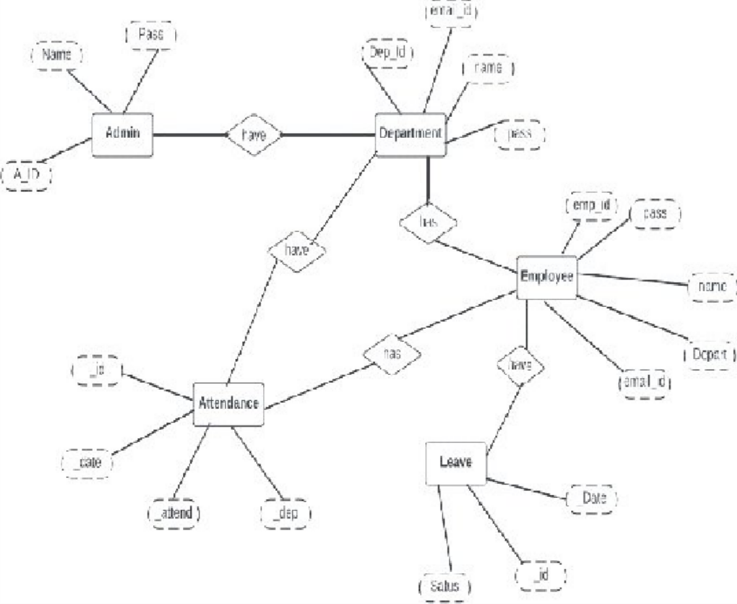

Figure -Entity Relationship Diagram

## Database Design:

### LOGIN TABLE:

* To create a Log In details for the table.

|  |  |  |  |
| --- | --- | --- | --- |
| **FIELDS** | **DATATYPE** | **CONTRAINTS** | **DESCRIPTION** |
| Table name | Varchar(20) | primary key | Stored number of  tables from log in |

## Department Table:

* To create user name and password for the Department details.

|  |  |  |  |
| --- | --- | --- | --- |
| **FIELDS** | **DATATYPE** | **CONSTRAINTS** | **DESCRIPTION** |
| Department id | Varchar(20) | primary key | Define  separate Department  id |
| name | Varchar(15) | Not Null | Short Department  name |
| Password | Varchar(20) | Not Null | Department log in password |

Table: -Department Table

## Employee table:

* To create table for Employee personal details for our department.

|  |  |  |  |
| --- | --- | --- | --- |
| **FIELDS** | **DATATYPE** | **CONSTRAINTS** | **DESCRIPTION** |
| Employee id | Varchar(25) | Primary key | Employee ID |
| Password | Varchar(20) | Not Null | Employee log in |
| Name | Varchar(50) | Not Null | Employee name |
| Department id | Varchar(30) | Not Null | Department name |
| Email id | Varchar(30) | Not Null | Employee E-mail id |
| phone | Varchar(20) | Not Null | Employee Mobile no |

Table:-Employee Table

## Leave table:

* To create the subject time table for a particular class.

|  |  |  |  |  |  |  |  |  |
| --- | --- | --- | --- | --- | --- | --- | --- | --- |
| **FIELDS** | | **DATATYPE** | **CONSTRAINTS** | | **DESCRIPTION** | |  | |
| Date Range | Date | | | Primary key | | Date Rage Store the Period of Leave |  | |
| Approve Status | | varchar(20) | Not Null | | set the approve and not approve  status | |  |  | |
| Request at | | Date Time | Not Null | | set the particular  date leave request | |
| Update at | | Date Time | Not Null | | set the Update the Leave  date time | |
| Reason | | Varchar(20) | Not Null | | set the particular  reason text. | |

Table: Leave Table

## Attendance table:

* To create attendance details for particular class.

|  |  |  |  |
| --- | --- | --- | --- |
| **FIELDS** | **DATATYPE** | **CONSTRAINTS** | **DESCRIPTION** |
| Dates | Date | Primary key | Enter day by  day |
| Hour | Number | Not Null | particular working hour only |
| Department | Varchar(15) | Not Null | Particular Department |
| Employee id | Varchar(20) | Not Null | Enter Present absent details in particular  Employee |

Table: -Attendance Table

## INPUT DESIGN:-

Input design is part of overall system design that requires special attention designing input data is to make the data entered easy and free from errors.

The input forms are designed using the controls available in Flutter framework.

Validation is made for each and every data that is entered.

Help information is provided for the users during when the customer feels difficult.

Input design is the process of converting the user originated inputs to a computer based format.

A system user interacting through a workstation must be able to tell the system whether to accept the input to produce reports.

The collection of input data is considered to be most expensive part of the system design. Since the input has to be planned in such a manner so as to get relevant information, extreme care is taken to obtain pertinent information

This project first will entered to the input of allocation forms it will be created on Employee details form and Department form, Attendance table form .it will helps to calculate Department wise attendance system.

Next one if you want any verification on your data’s also available in details show forms.

## OUTPUT DESIGN:-

Output design this application “**Employee Attendance management system”** generally refers to the results and information that are generated by the system for many end-users; output is the main reason for developing the system and the basis on which they evaluate the usefulness of the application.

The output is designed in such a way that it is attractive, convenient and informative. Forms are designed with various features, which make the console output more pleasing.

As the outputs are the most important sources of information to the users, better design should improve the system’s relationships with us and also will help in decision making. Form design elaborates the way output is presented and the layout available for capturing information.

One of the most important factors of the system is the output it produces. Attendance management system to show the report Department wise attendance maintaining by Department. Taken as a whole report obtain on administrator privileges only.

This forms will show monthly report and consolidate to our end user.